PORTUGAL
NAME OF THE GAME: | WOODEN SPINNING TOP
HOW MANY PLAYERS: | 1 or more players (boys game)
AGE OF PLAYERS: | 8+
WHERE IT IS PLAYED: | Outdoor/Indoor game
EQUIPMENT NEEDED: | Wooden spinning top, string and clear felt area

RULES OF THE GAME/INSTRUCTIONS
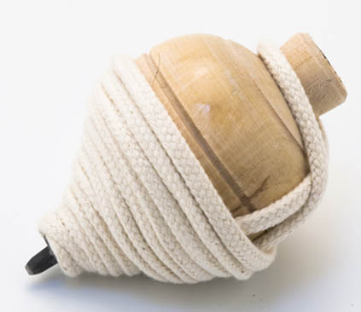  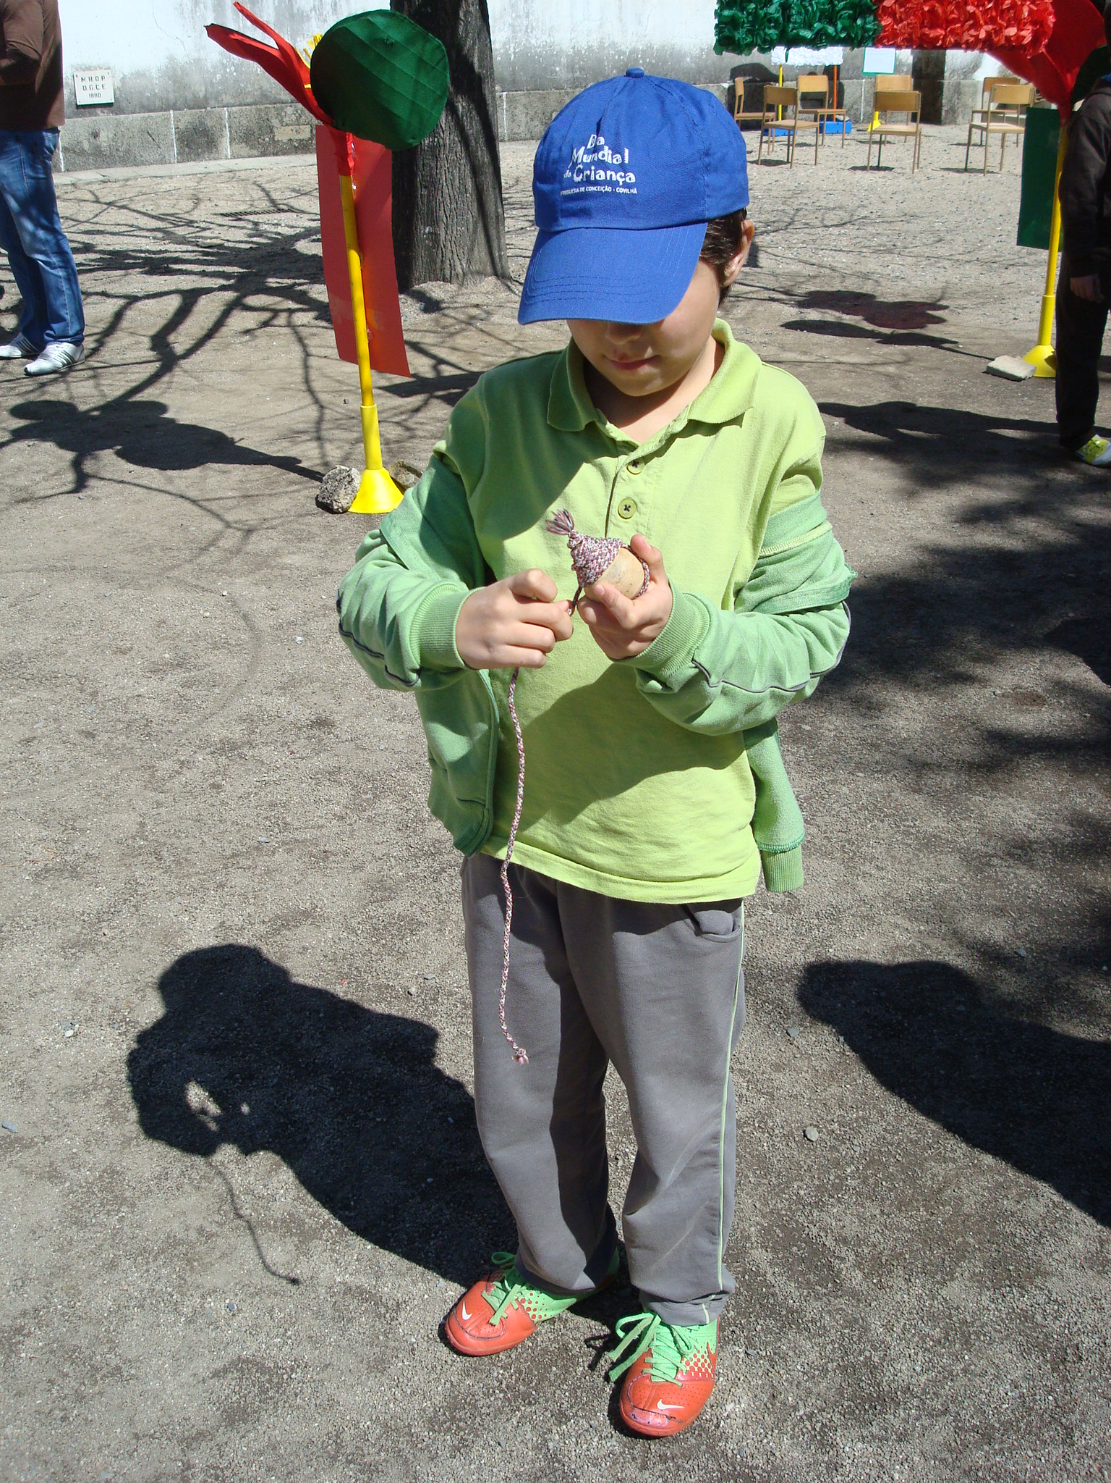  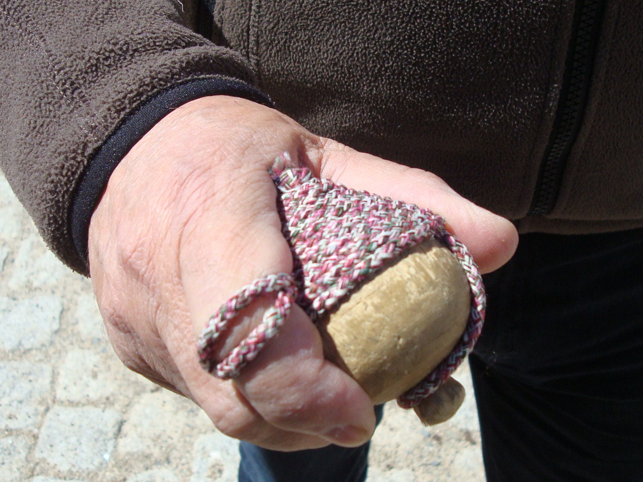  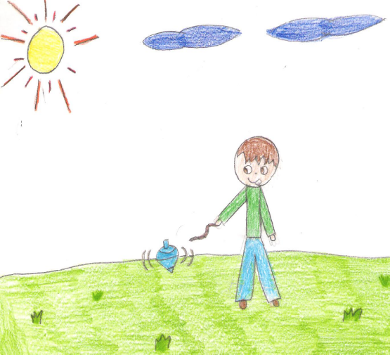 | 1- A circle with about 1,5m radius is drawn on the ground. In turns, all the players will threw their wooden spinning tops into this circle.  2- Before playing each player has to wind firmly the string around their spinning top from the bottom until half way to the top. Leaving quite a big piece of string unwound to put it around the hand. Then the end of the string which is around the hand is pulled backwards with the wrist and released as quickly as possible so that the string unwinds itself and makes the spinning top fall into the circle and starts spinning.  3- The spinning top has to spin within the circle and then gradually go out of it. If this doesn’t happen the spinning top stays within the circle as a “prisoner”.  4- The player whose spinning top stays within the circle is out of the game.  5- The other players with their spinning tops will try and remove the spinning top that has been left there by knocking against it with their spinning tops. This is called “picá-lo” (knock it). Every time a player is able to remove the other player’s spinning top wins fifty points.  6- In each game the spinning tops are release three times. The player with the highest points is the winner.
Note: The spinning top can be picked up from the ground while it is spinning and it will carry on spinning on the player’s hand. After it has spun on the hand the player will try and put it into the circle (always spinning) to knock out the other spinning tops and then out of the circle in order to carry on the game.

STUDENT: Rita Sousa (10) and her grandfather Eliseu Ramos (75)

