POLAND
NAME OF THE GAME: | The rolling of stove lids.
NUMBER OF PLAYERS: | Unlimited but it is suggested at least 2 players.  Teams should consist of 5-6 players.
AGE OF THE PLAYERS: | It doesn’t matter, but over 6 years old.
WHERE IT IS PLAYED: | On a large, flat area.
EQUIPMENT NEEDED: | A stove lid (heavy wheel). The best from a coal kitchen hanged on a hook, made of thick wire or properly curved poker.

RULES OF THE GAME/ INSTRUCTIONS
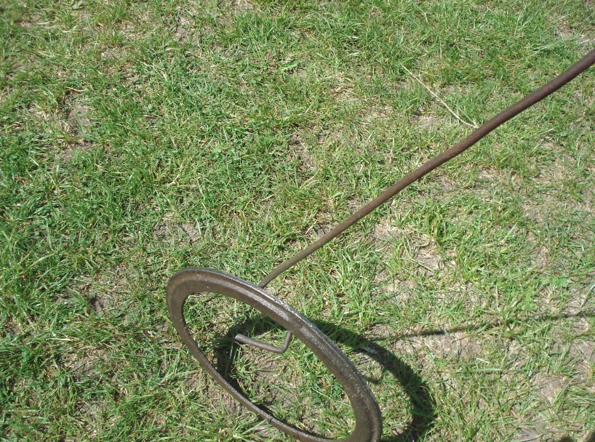  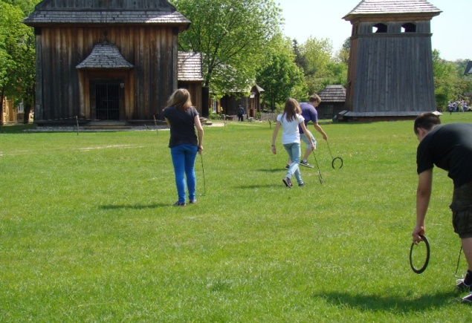  *Another type of the rolling stove lids is a competition between two teams. Before the game starts, you must choose an appropriate area. Each team must finish the route before the other team. The winner is the team which finishes the race first. | The aim of the game is training dexterity and balance or winning the race between two players, two teams or just for fun.  The rolling of stove lids is a social game. You have to roll a stove lid as long as possible, on the hook (a poker). You have to be very careful so that the stove lid not to slip out of the poker (hook) and roll as far as it is possible.  How to play the game?  - Before the start of a game the players stand next to each other.  - When the game begins, everybody runs with the stove lid.  - The aim is to roll them as far and as long as it is possible.  - The winner is the person who is the fastest and can roll the stove- lid the longest.  You have to remember that you must have your stove lid on the hook during a contest, it can’t slip out of it. If it happens, the player has to start the game again.  It’s possible to arrange the tournaments among the friends from neighbourhood and the best players can play in the final to win a title of the fastest and longest game champion.
Students: Karolina Cieśla, Kinga Sabat (15) and Karolina’s grandma Janina Babiarska (66)

