POLAND
NAME OF THE GAME: | The envelope
NUMBER OF PLAYERS: | 5 players (max)
AGE OF PLAYERS: | More than 6 years old
WHERE IT IS PLAYED: | somewhere, where you can draw an envelope, for example on a pitch  or a playground.
EQUIPMENT NEEDED: | flat pebble, chalk or stick.

THE RULES OF THE GAME/ INSTRUCTION
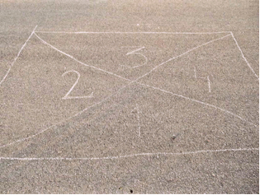  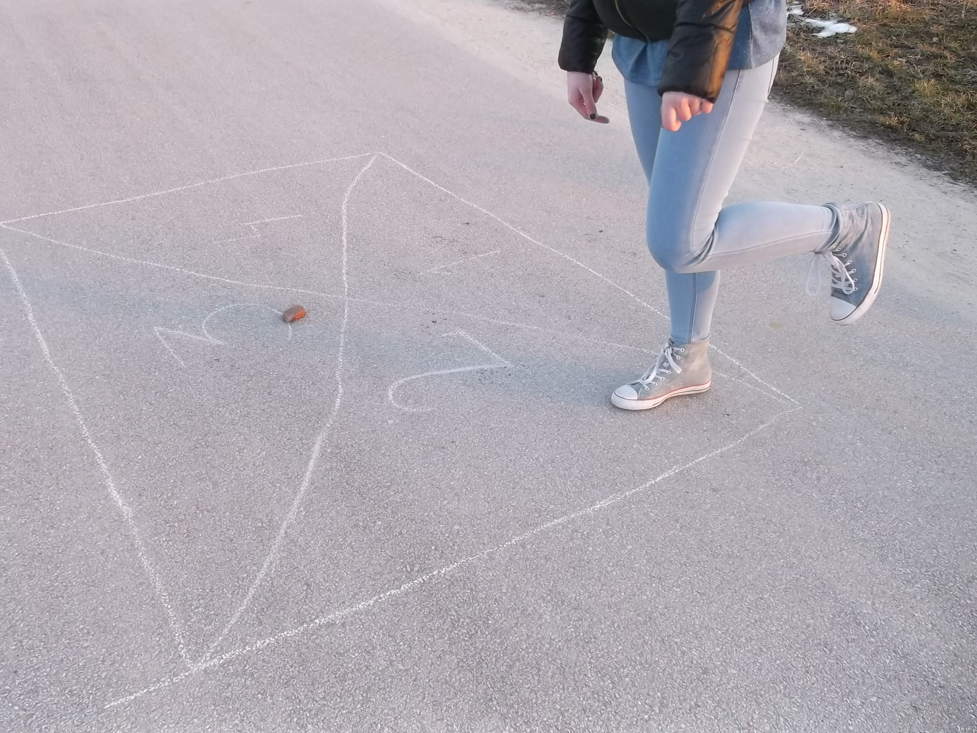 | 1. Draw a figure of an envelope on the ground, give a number to each field. Put a flat pebble on the first field. Player has to jump on one leg from field to field. The pebble can’t be dropped on the line between the fields, because in this situation player loses his turn.  2.When the player finishes his first round successfully, he goes to the second round, which consists of throwing the pebble on the second field. We do the same things like in the first round. The winner is the person who first completes all the fields, one by one.  3. Each level of the game is a higher level of difficulty, because the player must throw a stone further and it's really hard. Besides he has to maintain balance jumping from field to field.  4. This game requires precision and physical fitness from the players.

Students: Kinga Sabat (15) Magdalena Klimczak (15) and Kinga’s Grandmother (68)

