POLAND
NAME OF THE GAME: | The dodgeball game
HOW MANY PLAYERS: | Unlimited but even 11 players in a team during the game
AGE OF PLAYERS: | 7-16
WHERE IT IS PLAYED: | Outside (yard, pitch) and inside (gym)
EQUIPMENT NEEDED: | An inflated ball, sashes in two colours and six flags for outlining the field

RULES OF THE GAME/INSTRUCTIONS
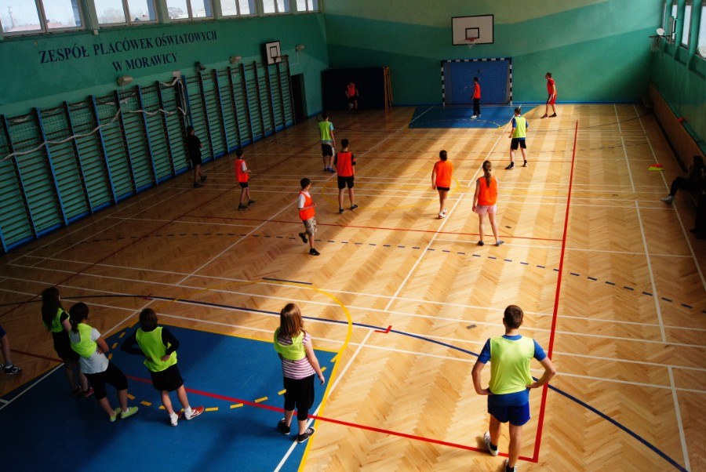 | The aim of a game:  to eliminate the members of the opposing team on the other side of the field.  The placing  The players, divided in terms of the number and strength in two equal teams, they choose their captains and must take one half of the field, standing in the loose cluster. Next, the captains fight for the beginning of the game trying to throw the ball to their team tossed by the coordinator. The captains stand behind the opponent's field and they take him in a crossfire by throwing the ball from and to their teams.
Game description
The player, who catches the ball at the beginning of the game, throws it against the opponents. They must protect themselves against hitting by such movements as ducking, jumping or escaping to the most distant angle of their field, trying not to cross its borderlines. If any player hits the escaping opponent, the beaten person stands by his captain and helps him to ‘heighten the fire’.
If the ball rolls out of the field, nobody is allowed to run after it. The ball is taken by the captain on his part of the field. Every player can get the knock-out ball for his team if he lies down having both feet on the field and he can reach the ball. The player, who rolls or comes out of the field on both feet (or even one foot), is a „beaten” person. In this way, there are more and more players standing by the captain, and less and less players inside the field.
After beating everyone, the captain goes in the field. He has the right to be beaten three times. This team wins, which earlier eliminated the opponents with their captain. If the game is supposed to continue, the winning team gets one point.

Student: Justyna Nogajczyk (13) and her grandpa Edward Nogajczyk (86)

