POLAND
NAME OF THE GAME: | The caps’ game
HOW MANY PLAYERS: | Unlimited but it’s suggested to have 4-5 players
AGE OF PLAYERS: | Over 6 years olds
WHERE IT IS PLAYED: | Classroom, gym, yard, beach
EQUIPMENT NEEDED: | Wool, plasticine chalk, a set of bottle caps, masking tape

RULES OF THE GAME/INSTRUCTIONS
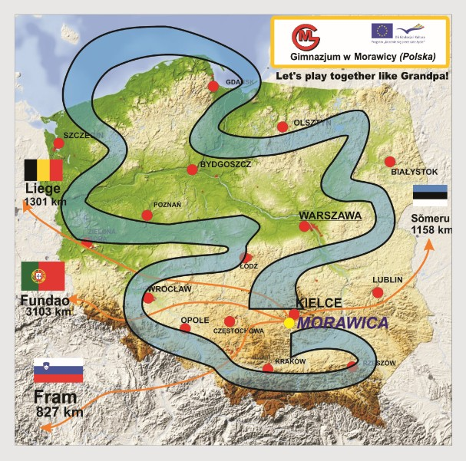 | The aim of the game is winning the race and to overcome all obstacles which are placed on the whole length of the route.  How to play the game?  1. The game starts at the starting line and the players draw lots.  2. The participant has only one hit during one turn.  3. The cap always needs to follow the route. You mustn’t take any shortcuts.  4. The cap needs to stop within the route set by the lines or needs to touch it.  5.If the cap after being snapped is out of the trail, the player must come back to the previous place both after the player’s hit or after being hit by the opponent’s cap.  6. The game of a player is finished if his/her cap crosses the finish line with its circumference.
The point of the game is a racing track which may be built both outside and inside(playground, pavement, classroom). You should take into consideration any obstacles such as sharp curves, bridges, tunnels, etc. You need to snap the bottle caps. The winner is the person who can hit them the strongest and the most precisely.
It’s possible to arrange the tournaments among the friends from neighbourhood and the best players will be playing in the finale to win a title of the game champion.

*Another type of the caps’ playing is an individual race of the participants. Each player must finish the route himself. The winner is that person who finishes the race by using the smallest amount of movements.

Student: Agnieszka Lenartowicz (15) and her grandma Maria Musik (62)

