SLOVENIA
NAME OF THE GAME: | Jumping over the rope
HOW MANY PLAYERS: | Suitable for any number of players
AGE OF PLAYERS: | 6 - 14
WHERE IT IS PLAYED: | Outdoors
EQUIPMENT NEEDED: | a rope/a skipping rope

RULES OF THE GAME/INSTRUCTIONS
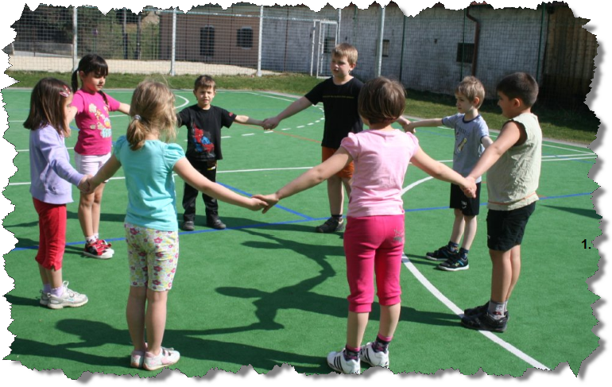  1..  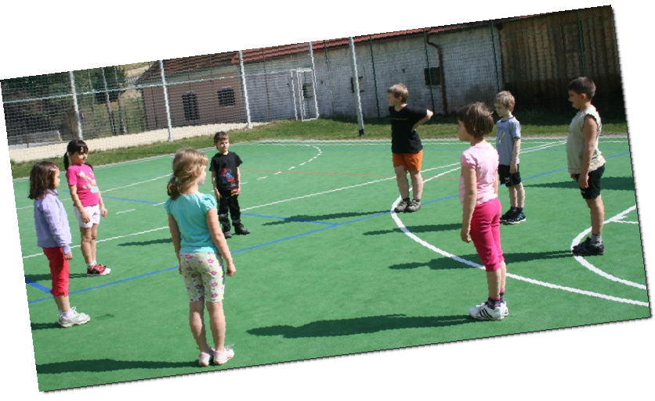  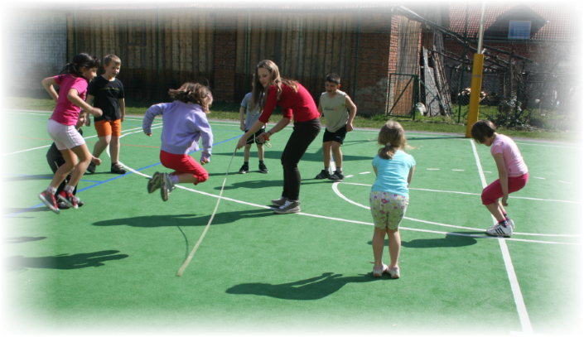  2.. | One of the children stands at a spot and lays at least two-metre-long rope on the ground.  The other children are standing around him in a circle.  The child in the middle starts spinning the rope while the other children are jumping over it.  The child who doesn't manage to jump across the rope drops out of the game. The other children continue with the game.  5..
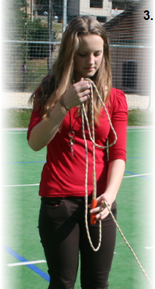
3..

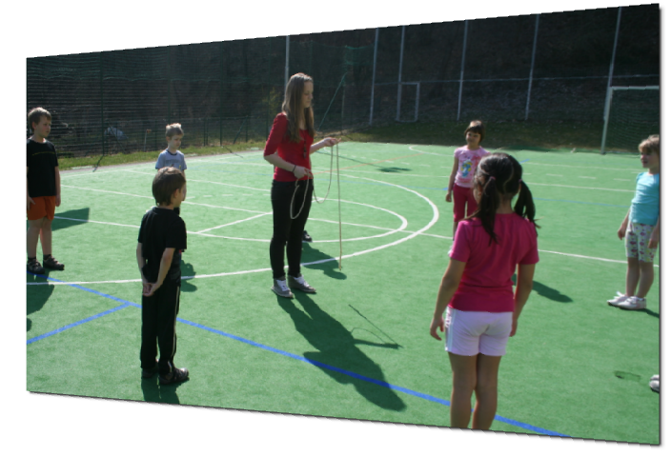
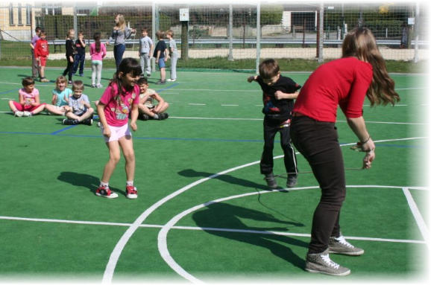
4..

6..

Written by Nuša Belas (8) and her grandpa Mirko Poterč (70)

