BELGIUM
NAME OF THE GAME: | The little men
HOW MANY PLAYERS: | 2 and more
AGE OF PLAYERS: | 0-99
WHERE IT IS PLAYED: | Outdoor of indoor
EQUIPMENT NEEDED: | A ball, 5 skittles (little men) and a gallow

RULES OF THE GAME/INSTRUCTIONS
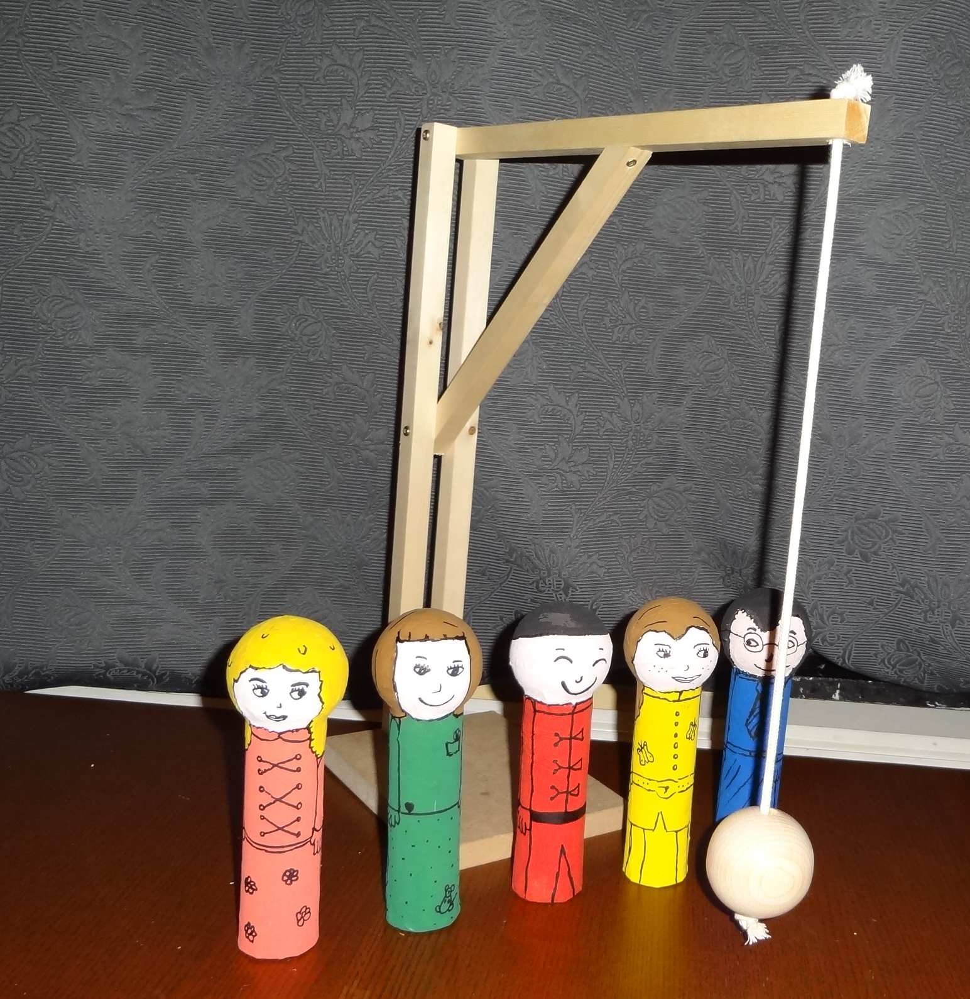 | Place the 5 skittles between the wooden ball and the gallow.  Throw the ball toward the skittles.  The goal is to knock down as many skittles in two shots.  For this, it is recommended to throw the ball with a circular path so you can bring down several skittles at once.  The player that brings down a maximum of little men (skittles) wins.

Student: Elementary school

