SLOVENIA
NAME OF THE GAME: | LAND STEALING
HOW MANY PLAYERS: | 5
AGE OF PLAYERS: | 10-14
WHERE IT IS PLAYED: | Outdoor
EQUIPMENT NEEDED: | Chalk and wooden stick

RULES OF THE GAME/INSTRUCTIONS
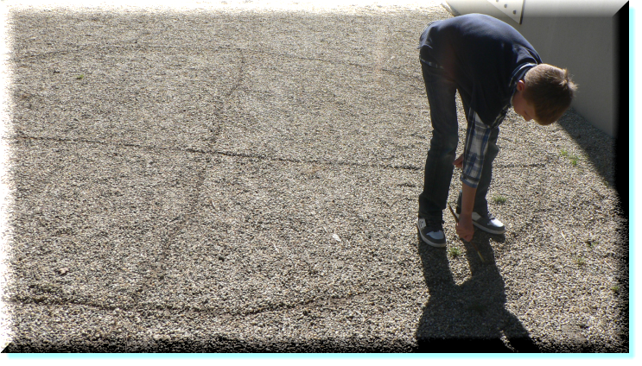  1..  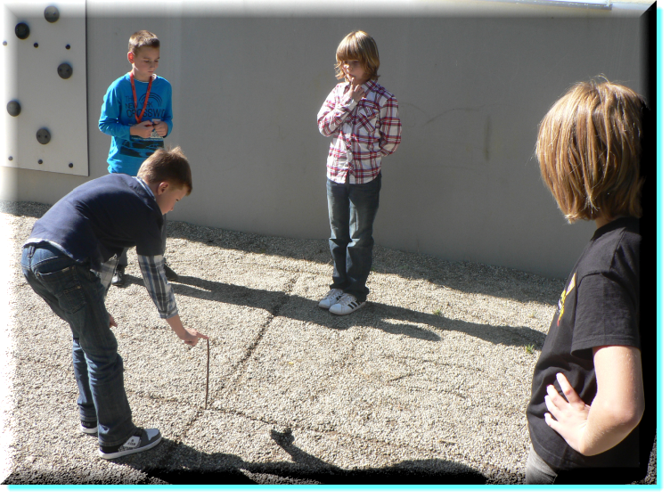  2.1..  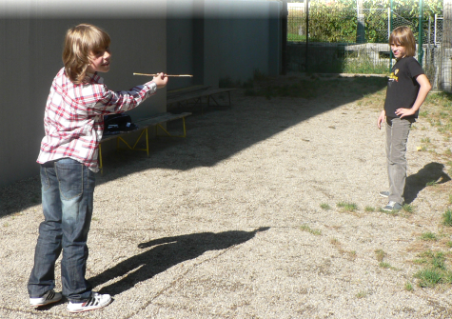  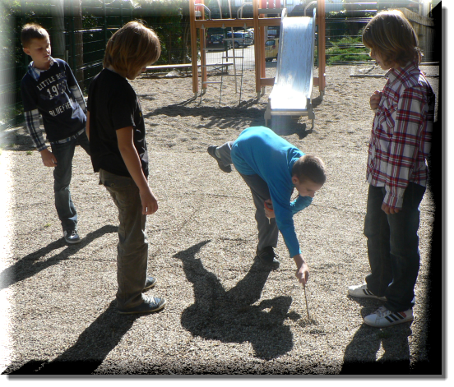  3.1..  4.1.. | Use a chalk (on a hard surface like asphalt) or a stick (on soil) to draw a large circle representing the land (estate). Then divide it into as many parts as there are players. Each field represents one country. Every player chooses one and labels it with his/her name.  To start the game put the stick in the middle of the circle (held by one of the players). All the players stand in their own fields. The stick is dropped. The player of the field into which the stick falls, has to pick it up and throw it into one of the remaining fields and yell the country’s name at the same time.  All except the provoked land owner have to run out of the circle as far as possible. The one that gets the stick has to step on it quickly and call out ‘Stop!’ At that sound all the players have to stop running.  The challenged one has to hit one of the players with the stick. If he is successful, then (s)he can "steal land" from the one (s)he hits, if (s)he fails, then the other one steals land from him/her.  While stealing it is allowed to stand in one’s own country and draw a line only as far as it can be reached. The winner is the one who steals the biggest portion of land.
Written by Žiga Cehtl (6) and her grandpa Dragica Cehtl (55)

