POLAND
NAME OF THE GAME: | An old bear sleeps hard
NUMBER OF PLAYERS: | At least 6 players
AGE OF PLAYERS: | 3-10 years old
WHERE IT IS PLAYED: | Classroom, pitch, playground, gym
EQUIPMENT NEEDED: | -

THE RULES OF THE GAME/ INSTRUCTION
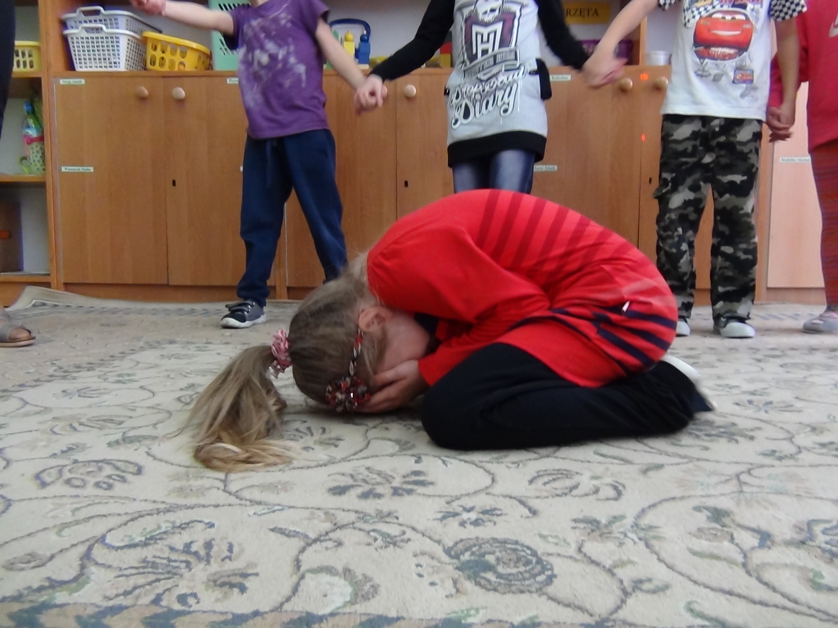  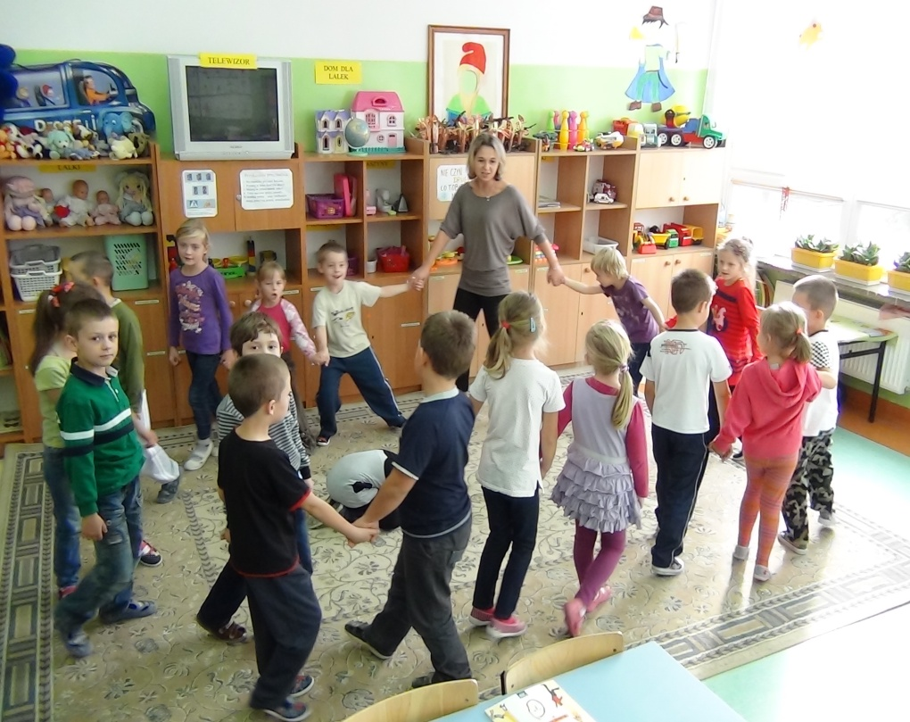  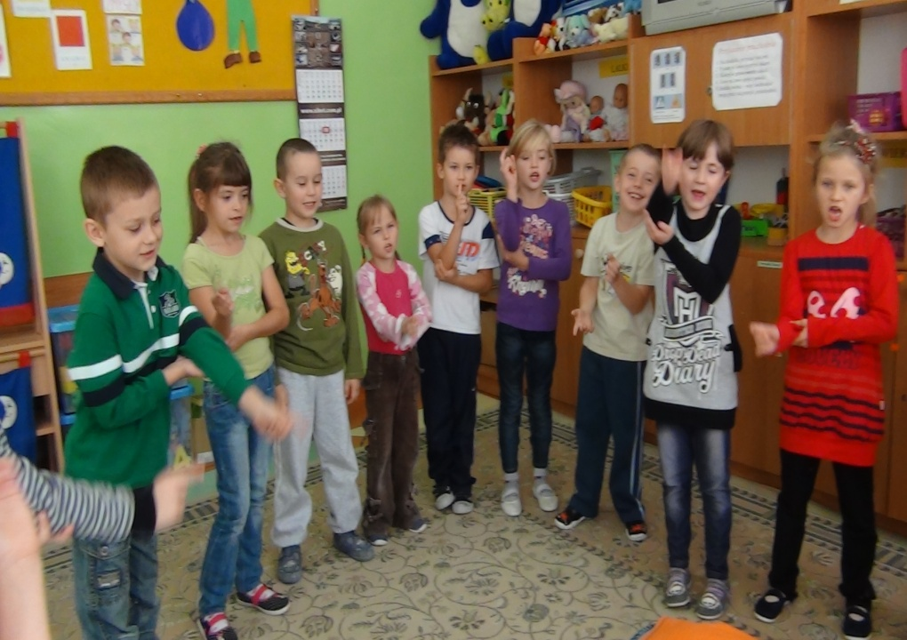 | The rules of the game.  1.The children are choosing person who will be the bear which must squat in the middle of the circle and also pretend to sleep.  2.The children are singing and walking along the bear on their toes in order not to wake him up. They’re singing:  “The old bear sleeps hard  The old bear sleeps hard  We’re scared of him, we’re tiptoeing  If he wakes up, he’ll eat us  (They start counting and pointing at the bear)  The first hour the bear sleeps  The second hour the bear snores  The third hour the bear catches!  Option1  While the words: “The third hour the bear catches”, the bear gets up and tries to grab the children who must run away. The caught child goes to the circle to play the bear’s role. The game starts again.  Option 2  The participants of the game are squatting fast and meanwhile the bear must catch the person who is slower and doesn’t manage to stand up after squatting on time. The person caught by the bear goes to the circle and play the bear’s role.
Student : Paweł Bożek-Raćkos (9) and his grandpa Andrzej Bożek (67)

