SLOVENIA
NAME OF THE GAME: | A Cockfight
HOW MANY PLAYERS: | Suitable for an even number of players
AGE OF PLAYERS: | 5 - 99
WHERE IT IS PLAYED: | Outdoor or indoor game
EQUIPMENT NEEDED: | /

RULES OF THE GAME/INSTRUCTIONS
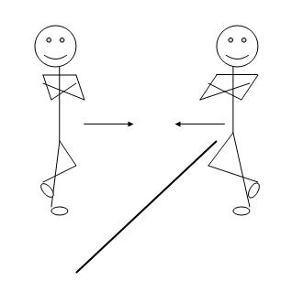 | - Two children stand on one foot and cross their arms on their chest.  - They face each other. A line is drawn between them.  - They try to push their opponent away and cross the line without stepping on both feet and letting go of their arms.  - The winner is that cock who pushes away the opponent and crosses the line.

Written by Nuša Ačko (7) and her grandpa Janez Štern (68)

